

CSE302 (Section 1)
[Summer 2022]

Lab Assignment Submission Report

Assignment Title: Lab tasks of LAB02

Submitted by:
Aisha Siddika Mim
2020-1-60-040

1. Screenshots

LAB TASK 01:

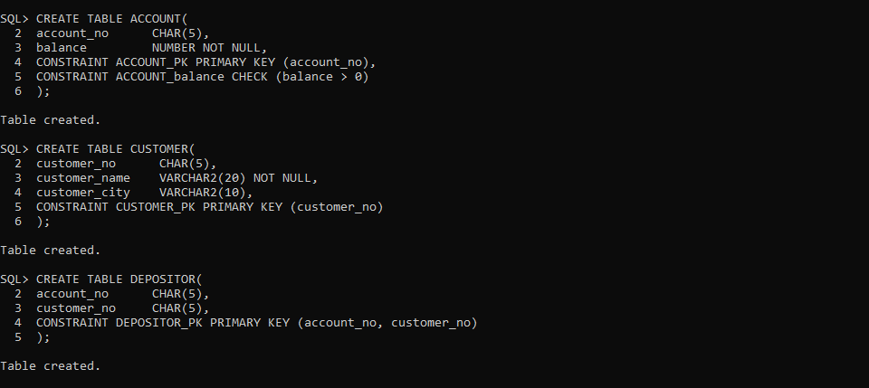

LAB TASK 02 (i):

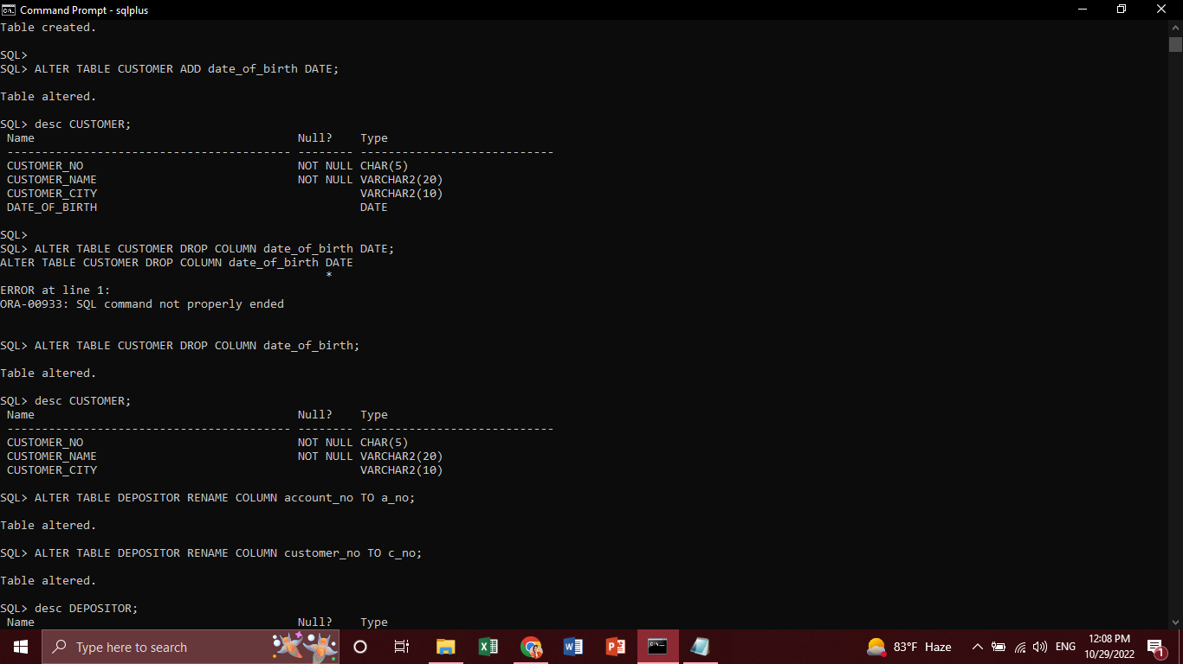

LAB TASK 02 (ii):

LAB TASK 02 (iii):

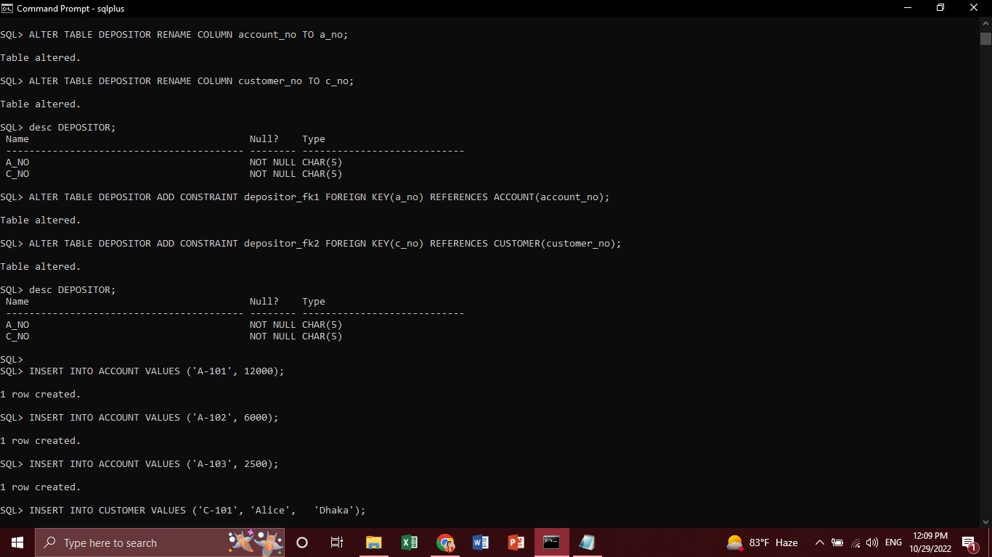

LAB TASK 02 (iv):

LAB TASK 03:

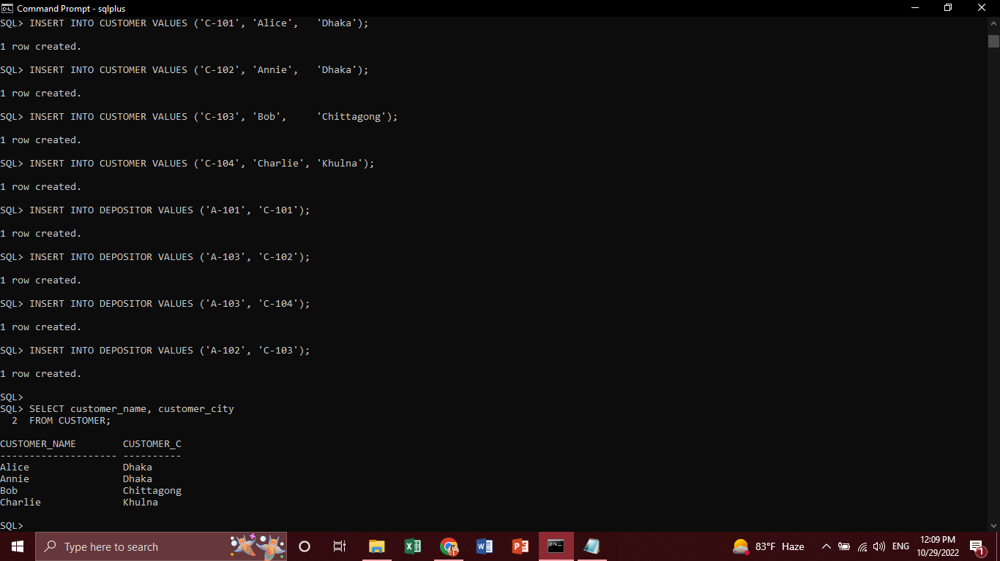

LAB TASK 04 (i):

LAB TASK 04 (ii):

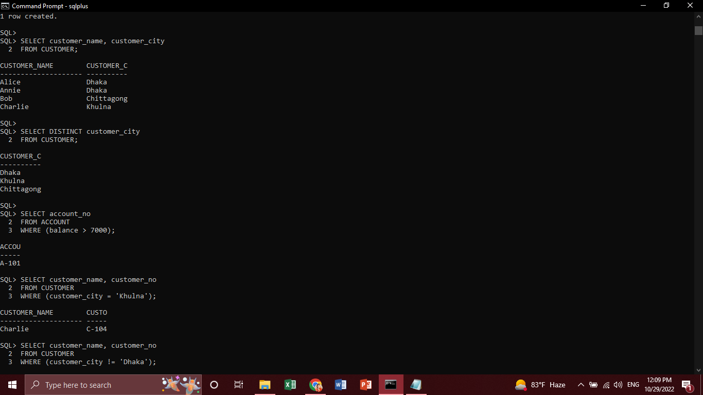

LAB TASK 04 (iii):

LAB TASK 04 (iv):

LAB TASK 04 (v):

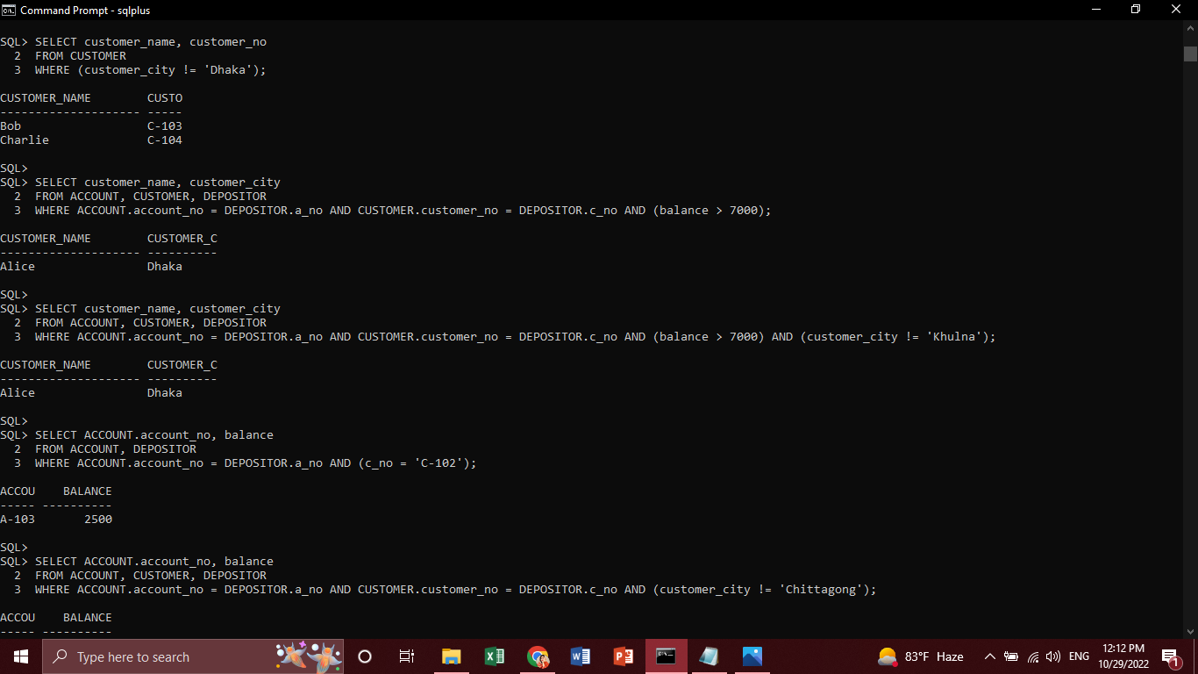

LAB TASK 04 (vi):

LAB TASK 04 (vii):

LAB TASK 04 (viii):

LAB TASK 04 (ix):

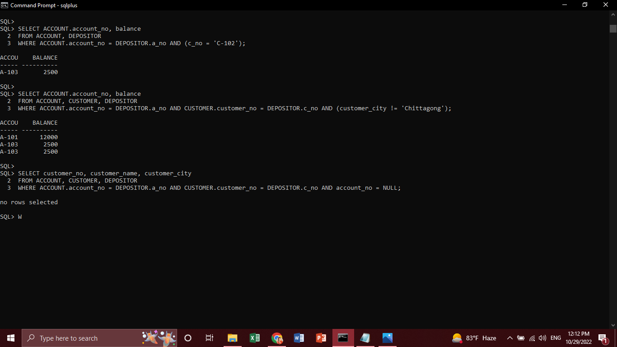

LAB TASK 04 (x):

2. Learning Outcomes

Previously, I learned how to create tables, insert, update and delete data, the process of identifying and declaring primary and foreign keys, how to show the information of that table based on given requirements and do all these on command prompt.

By doing this lab, I learned how to alter the tables by adding, dropping and renaming the constraints, columns, attributes. Also the previously learned things has been very clear by practising those works in this lab.

